IEEE 802.11 standard, popularly known as WiFi, lays down the architecture and specifications of wireless LANs (WLANs). WiFi or WLAN uses high-frequency radio waves instead of cables for connecting the devices in LAN. Users connected by WLANs can move around within the area of network coverage.

IEEE 802.11 Architecture

The components of an IEEE 802.11 architecture are as follows −

* **Stations (STA)** − Stations comprises of all devices and equipment that are connected to the wireless LAN. A station can be of two types−
  + Wireless Access Point (WAP) − WAPs or simply access points (AP) are generally wireless routers that form the base stations or access.
  + Client. Clients are workstations, computers, laptops, printers, smartphones, etc.
* Each station has a wireless network interface controller.
* **Basic Service Set (BSS)** − A basic service set is a group of stations communicating at the physical layer level. BSS can be of two categories depending upon the mode of operation−
  + Infrastructure BSS − Here, the devices communicate with other devices through access points.
  + Independent BSS − Here, the devices communicate in a peer-to-peer basis in an ad hoc manner.
* **Extended Service Set (ESS)** − It is a set of all connected BSS.
* **Distribution System (DS)** − It connects access points in ESS.

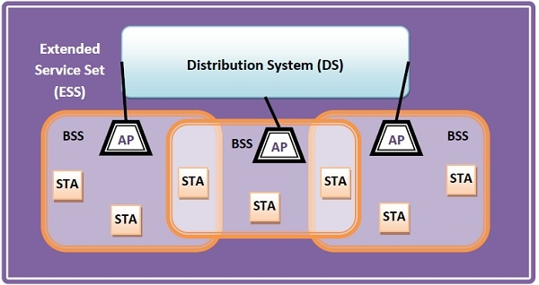

Frame Format of IEEE 802.11

The main fields of a frame of wireless LANs as laid down by IEEE 802.11 are −

* **Frame Control** − It is a 2 bytes starting field composed of 11 subfields. It contains control information of the frame.
* **Duration** − It is a 2-byte field that specifies the time period for which the frame and its acknowledgment occupy the channel.
* **Address fields** − There are three 6-byte address fields containing addresses of source, immediate destination, and final endpoint respectively.
* **Sequence** − It a 2 bytes field that stores the frame numbers.
* **Data** − This is a variable-sized field that carries the data from the upper layers. The maximum size of the data field is 2312 bytes.
* **Check Sequence** − It is a 4-byte field containing error detection information.

